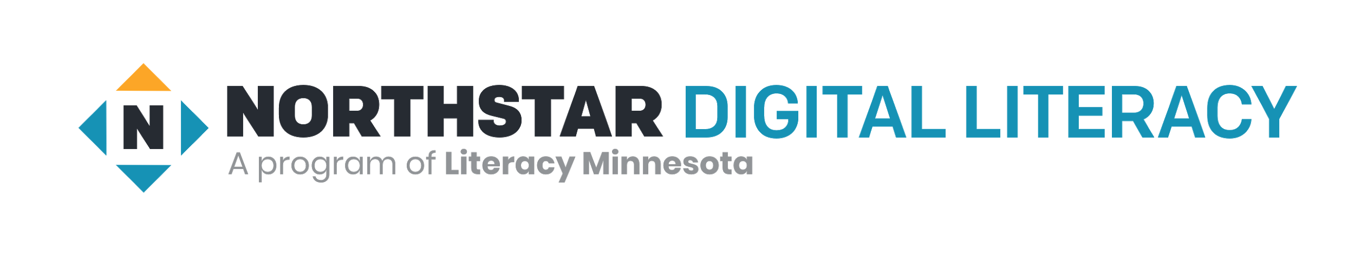
Hello Northstar Test Taker,

Please use this checklist to get ready to take the Northstar Assessment Online.

You will need:

- A computer (tablets and smartphones will NOT work)

- Internet access

- A webcam (video camera) on your computer 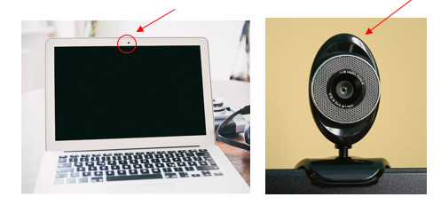

- A quiet space

- A phone to contact the proctor if you have technical problems

- A picture ID - *the proctor only needs to see your picture and full name. There may be other test takers in the online meeting. Cover up your ID number and address with your hand or piece of paper. If you do not want to share your full name with other test takers, please let the proctor know.

- Please read the Test Taker Code of Conduct on the next page before taking the test.

Important information about your test:

- You will test at [insert date/time here]. Please plan for 1 hour of time.

- Use this link to connect to take the test: [insert video conferencing invite link here]

- If you have technical questions or problems with the link above, please call [insert phone number here]

Test Taker Code of Conduct
If a test taker violates the code of conduct, the proctor will ask the test taker to stop the assessment.
- Test taker must listen carefully to all instructions given by proctor.
- Test taker must treat others with courtesy and respect during the assessment process.
- Test taker should ask questions prior to the assessment if they are uncertain about the certification process.

- Test taker should inform the proctor in advance of any accommodations needed.
- Test taker must represent themself honestly during the assessment.
- During the assessment, test takers must put away all notes and electronic devices (except technology necessary for assessment).

- Test taker should inform the proctor if the assessment conditions affected the results.
- All test takers planning to take the assessment must present a current identification with their name and photo before being allowed to take the assessment to gain certification.

- Acceptable forms of ID include passports, foreign and domestic state-issued ID cards, school ID cards, human services cards, military ID cards and similar identification.

